**MEASURING SUCCESS IN TALENT MANAGEMENT**

**1)INTRODUCTION**

* 1. **Overview**

It includes various methods and tools, which range from intuition and simple interviews to sophisticated online psychometric measures, and rigorous assessment centre simulations. At a micro level, talent measurement produces data about individuals (strengths, development needs, aspirations, and job-fit).

* 1. **Purpose**

The purpose of talent management is to identify, recruit and hold on to people who drive the success of your organisation.

It’s a top priority, strategic process for forward-looking People Companies who understand that their company performance depends on their workforce.

Performance and talent management is a key function of the modern HR department.

These People Companies go out of their way to nurture and develop the talent that powers their growth and effectiveness.

**2) PROBLEM DEFINITION & DESIGN THINKING**

* 1. **Empathy Map**

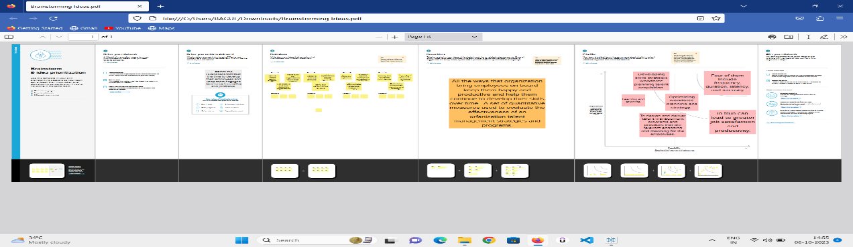

**2**.**2 Ideation & Brainstorming Map**

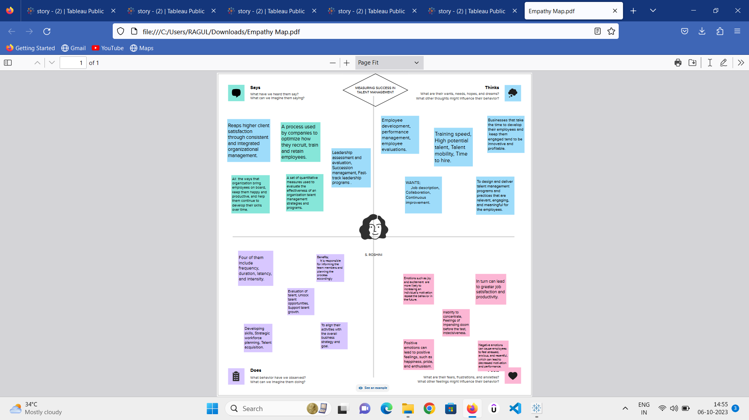

1. **RESULT**

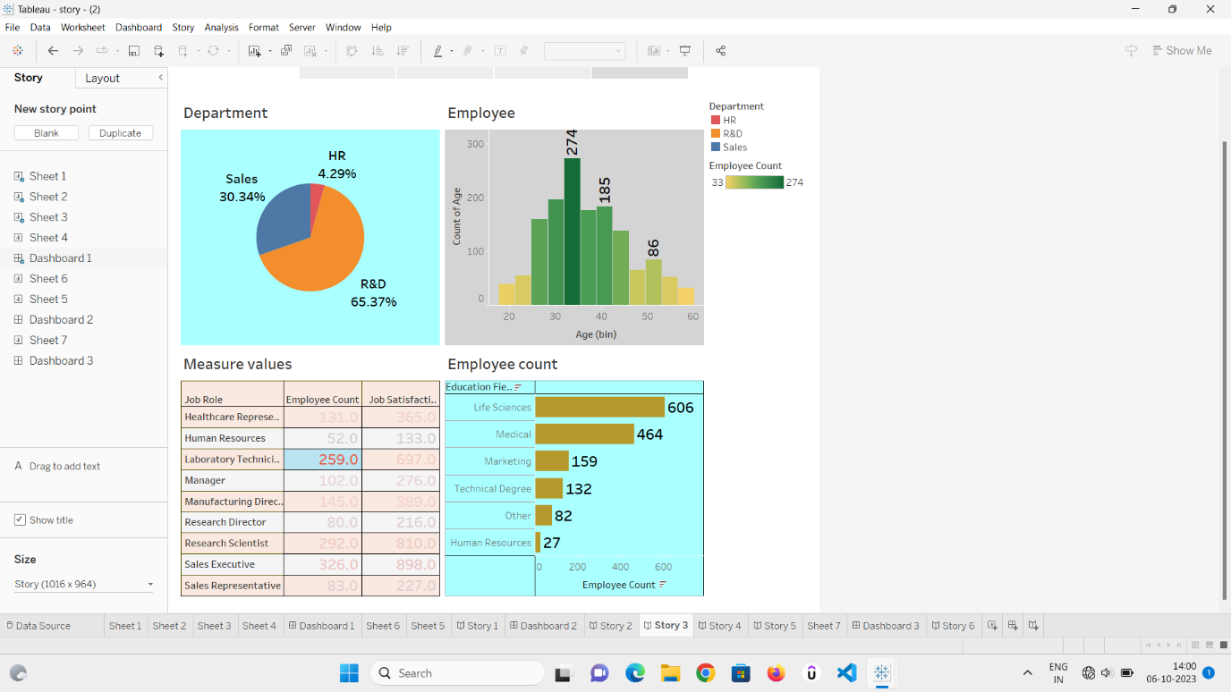

**4) ADVANTAGES & DISADVANTAGES**

* **ADVANTAGES**

Help in ascertaining the right person is deployed in the right position.

Contributes in retaining their top talent.

Better hiring by hiring assessments

Helps in understanding employees better and shaping their future.

Promotes effective communication across different disciplines.

* **DISADVANTAGES**

The implementation of talent management program could be expensive in terms of time, resources and financial costs.

Lack of support from line mangers can impede the level of commitment from employees.

A core drawback of talent management is, it can contribute in raising the conflicts between HR and management by not reaching to proper agreement or consensus.

1. **APPLICATIONS**

Talent management software provides many advantages in the areas of recruitment, performance management, training and education, and compensation management. Companies can collect, centralize, track, store, report and analysis employee data, while receiving automated reminders and notifications.

1. **CONCLUSION**

To measure success effectively, it's crucial to identify and track relevant Key Performance Indicators (KPIs) for each aspect of talent management. KPIs could include metrics such as employee turnover rates, time-to-fill positions, training completion rates, and employee satisfaction scores.

1. **FUTURE SCOPE**

It typically includes recruitment, hiring, engagement, development, performance management, recognition, and succession planning.

1. **APPENDIX**

Talent management is the full scope of HR processes to attract, onboard, develop, motivate, and retain high-performing employees. Talent management is aimed at improving business performance through practices that make employees more productive.